Caitlyn McGinley

Research Ecology: Intro

M. Denny and R. Elahi

6/6/19

**Microalgae influence on the temperature of *Lottia gigantea***

**Abstract:**

*Lottia. gigantea* is a keystone species in the rocky intertidal zone (Paine, 1994). Better understanding of *L.gigantea* will provide further insight to the community ecology of the rocky intertidal zone. While in the field at Cabrillo Point, I observed facilitative interactions between L*.gigantea, L.scabra,* and microalgae. Two field sites were created to investigate temperature differences between limpets with microalgae on their shell and those without. Limpets were studied for three days. At site and on each day, limpets with microalgae were .383 degrees Celsius warmer than limpets without microalgae. In addition, I discovered a significant main effect of site on the difference in temperature between limpet with algae and limpets without (p-value = .00451). My finding provokes further investigation of the interesting relationship between microalgae and limpet shell temperature.

**Introduction:**

The rocky intertidal zone is a model system for examining relationships between abiotic stresses, biotic interactions, and ecological patterns (Paine, 1994). Due to the nature and variability of thermal and desiccation stresses, the rocky intertidal serves as a prime environment to investigate physiological stress and thermal adaptations. Previous studies have shown that in environments with extreme abiotic stressors, like the rocky intertidal, there is an increase in facilitative interactions (Silliman et al., 2011), species interactions that benefit at least one of the participants and cause harm to neither (Stachowicz, 2001). The stress‐gradient hypothesis, which predicts that facilitative interactions will be more common in conditions of high abiotic stress (Maestre, 2009), supports the rocky intertidal as a model ecosystem for study of facilitation in community ecology. Facilitation among species produces community-level effects through individual interactions, impacting spatial structure, diversity, and invasibility of the ecological community (Maestre, 2009).

*Lottia gigantea*, commonly known as the owl limpet, is an intertidal mollusk typically found on rocky, wave-exposed shores grazing on algal biofilms (Denny and Blanchette, 2000). Adult *L. gigantea* are a major competitor for primary space on rocky shores along the west coast of North America (Shanks, 2002). *L. gigantea* create and maintain small, microalgae-encrusted territories on the rock (Galbraith, 1965; Stimson, 1970), and actively remove intruders such as mussels and other limpets from their territory (Lindberg et al., 1998). Previous studies suggest *L. gigantea* is a keystone species in the intertidal zone (Paine, 1994), greatly influencing the abundance of other species in the intertidal zone as a territorial habitat engineer (Fenberg and Rivadeneira, 2011).

On occasion, the smaller limpet *Lottia scabra* may be found atop the shells of *L. gigantea* for extended periods of time (Seanet, 2019). *L. scabra* and *L. gigantea* occupy the same geographic range in the rocky intertidal from northern California to Baja California, inhabiting multiple rock types from mid and high heights in intertidal zone (Fenberg and Rivadeneira 2011). Both limpets prefer wave-exposed rocks as their habitat of choice ([Nakano & Ozawa, 2004](https://onlinelibrary.wiley.com/doi/full/10.1111/j.1365-2699.2011.02572.x#b38); [Gilman, 200](https://onlinelibrary.wiley.com/doi/full/10.1111/j.1365-2699.2011.02572.x#b19)6). When *L. scabra* are not found atop *L. gigantea*, it has been observed that microalgae grow on *L. gigantea.*  Microalgae are a broad functional group, including autotrophs such as diatoms or dinoflagellates (Hitchcock, 1982). Microalgae in the rocky intertidal are consumed as food sources by many intertidal organisms such as limpets, barnacles, and mussels (Hitchcock, 1982), and must compete against macroalgae, such as red, brown, and green algae, for space on the rock (Hitchcock, 1982).

Little is known about the relationships between *L.gigantea, L.scabra* and microalgae, and there is a current lack of research on how species interactions between microalgae and *L.scabra* could affect thermoregulation of *L.gigantea.* Although Miller et al., (2009) investigated thermal and desiccation rates of *L. gigantea* using in-lab measurements of the production of heat shock protein 70 (Hsp70), there has been no research conducted as to how microalgae and/or *L. scabra* on the shell of *L.gigantea* influence body temperature.

As global temperatures rise due to anthropogenic climate change, the rocky intertidal may be a model system for understanding how other ecosystems will fare (Helmuth et al., 2010). Since *L. gigantea* is a major grazer and habitat engineer (Fenberg and Rivadeneira, 2011), this species does influence other species’ distribution and abundance in the intertidal zone. Investigating the effect of species interaction between *L.gigantea, L.scabra,* and microalgae on limpet temperature aids in understanding how facilitation can affect temperature.

I hypothesize that *L.gigante*a with microalgae on their shells are cooler than *L.gigantea* withoutmicroalgae. My hypothesis is based off the belief that the microalgae will keep *L.gigantea* generally cooler due to evaporative cooling.

**Preliminary Investigation**

Facilitation between *L.gigantea, L.scabra,* and microalgae was observed in my preliminary work, but the specific mechanisms of the relationships have not been explored. After observation in the field, it is assumed that *L.scabra* perch atop the shells of *L.gigantea* to eat the microalgae growing on the shells while avoiding competition for space on the rock. Just like *L.scabra*, microalgae also must compete with mussels and other sessile organisms for space on the rock (Hitchcock, 1982). This has resulted in microalgae growing on *L.gigantea* shells. Based on classical ecological theory, plants often develop facilitative interactions with other species to avoid predation and competition (Stachowicz, 2001). This could explain growth of microalgae on the shell of *L.gigantea*. It is assumed that *L.gigantea* do not benefit from either relationship as other models in classical ecological theory suggest plants most likely engage in commensal relationships to escape competition with other plants (Callaway, 1995).

During my preliminary investigation, I observed the relationship between *L.scabra* and *L.gigantea*. Even after multiple days of observation, the *L.scabra* I observed remained on the shells of the *L.gigantea* they were perched atop. I hypothesize that *L. scabra* are provided with improved food resources and refuge from competition as they are not threatened by the territorial nature of *L.gigantea* while perched atop their shell. *L.gigantea* with *L.scabra* on their shellhave notably less microalgae on their shell as compared to *L.gigantea* without *L.scabra* on their shell. This might be due to *L.scabra* consuming the microalgae. Due to these observations, further research into the relationships between *L. gigantea,* *L. scabra*, and microalgae is needed.

**Methodology:**

I used two study sites in the intertidal zone surrounding Hopkins Marine Station (Site 1 and 2) where *L. gigantea* have been observed. The sites are rocks roughly 10 meters in length, approximately 45 meters away from each other, and are in a wave-exposed area of Cabrillo Point. The sites were selected due to their large population of *L.gigantea*.

At each site, I selected 40 individual limpets. Then I paired the limpets, establishing 10 pairs of limpets at each site. These pairs were selected on multiple criteria, based on previous work in the intertidal zone: 1) one limpet had algae on its shell, the other did not; 2) the limpets were located within 1 meter of each other on the rock; 3) the limpets’ height on the rock was similar (Finke et al. 2007); 4) the limpets were similar in size, within 10 mm of shell length of each other; 5) both limpets experienced the same amount of wave splash ([Harley](https://besjournals.onlinelibrary.wiley.com/doi/full/10.1111/j.1365-2435.2009.01567.x#b43) et al., 2009).

Each limpet shell length was measured with a ruler. Their temperatures were recorded in degrees Celsius using a thermocouple thermometer. The thermocouple was placed on the center of the shell as it was not possible to place the thermometer on the fleshy body of the limpet because of how closely *L.gigantea* sits parallel to the rock. Using a compass, rock face direction, or the direction in which the rock was pointing at relative to true North, was recorded. Then, the limpet’s preferred angle on rock, meaning whether they preferred a flat surface, slightly slanted surface, or vertical surface, to cling to was estimated using 0 degrees as horizontal, 45 degrees being slightly slanted, and 90 degrees being completely vertical. The number and size of *L.scabra* perched atop the shell of *L.gigantea* was also recorded. The *L.scabra* that were perched atop *L.gigantea* were painted in effort to determine if *L.scabra* leave the shell of *L.gigantea*. Finally, after all measurements were recorded, all the limpets were dried, their shells were sanded and then painted with nail polish. At each site, the pairs of limpets were painted with unique colors and patterns. For simplicity, the colors were converted to alphabetical identifiers for the data set.

Each pair of limpets had their temperatures recorded on 3 different days otherwise known as “sessions” in the raw data. Each day, temperature was recorded using the thermocouple, wind speed was recorded based off data taken from the National Data Buoy Center – site 46092, and solar irradiance was recorded using Hopkin’s weather station. The air temperature and wind speed were not recorded from Hopkin’s weather station as the that data was not available. Time of day was also noted before working at each site*.*

The results for the paired *L. gigantea* were studied using a paired t-test. The difference in temperature between the paired limpets with and without algae was recorded. Then, using the difference in temperature, a paired T-test was performed to see if there was a significant difference in temperature between bare and algae covered limpets.

Lastly, a two-way Analysis of Variance (ANOVA) examined the effect of multiple factors (site and session) on the dependent variable – difference in temperature between *L.gigantea* with microalgae and *L.gigantea* without microalgae. Because the two-way ANOVA considers the effect of two categorical factors (site and session) and the effect of the categorical factors on each other, there are three pairs of null and alternative hypotheses for the two-way ANOVA:

* H01: The means of all site groups are equal.
* HA1: The mean of at least one site group is different.
* H02: The means of the session groups are equal.
* HA2: The means of the session groups are different.
* H03: There is no significant difference in difference in temperature between the site and session.
* HA3: There is a significant difference in difference in temperature between the site and session.

**Preliminary Results**

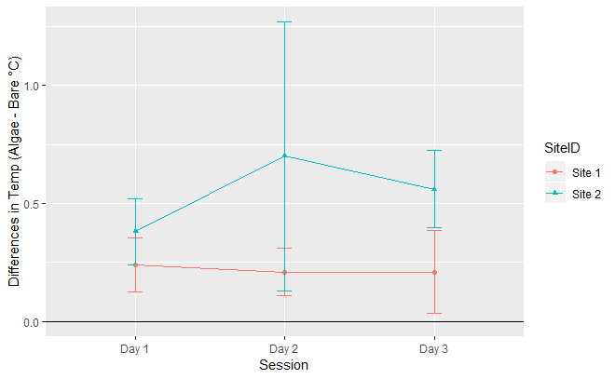

**Figure 1.** Differences in temperature (mean ± 95% ci) between paired limpets from two sites (Site 1 in red, Site 2 in blue), measured on three different days.

It can be concluded that each day at each site, the limpet with microalgae was warmer than the bare limpet (Figure 1). This conclusion can be drawn by looking at the error bars around the mean. The error bars representing the 95% confidence interval never reach the line at 0, and thus, it can be concluded that at each site and day, my sample of limpets with microalgae were warmer than the bare limpets. This disapproves my hypothesis that limpets with microalgae would be cooler than limpets without microalgae.

As a visual aid, individual limpet temperatures were displayed over the course of the three days in the field (Figure 2). The limpets are separated by site and treatment. Each day at each site, the limpet with algae was warmer than the limpet without algae, except on one occasion during Day 3 at Site 1. On average, the difference in temperature between the algae covered limpet and the bare limpet was 0.383 degrees Celsius.

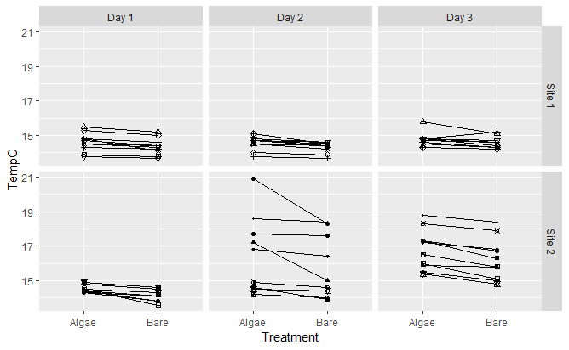

**Figure 2.** Difference in temperature based off treatment (algae versus bare) recorded on three separate days by site. The pairs of limpets are designated by different shapes and the solid black lines link the individuals together to show their pairing.

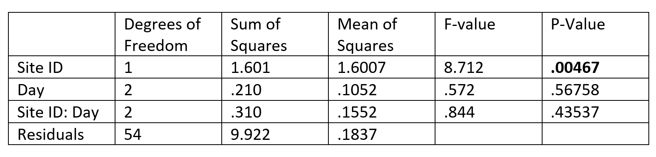Furthermore, the two-way ANOVA examined the effect of multiple factors (site and session) on the dependent variable (difference in temperature between *L.gigantea* with microalgae and *L.gigantea* without microalgae). In the ANOVA, there is a fixed effect of Site and Session.

**Table 1.** This table is the ANOVA table for the two-way ANOVA that examined the effect of Site ID and Day on the dependent variable, difference in limpet temperature. Bolded numbers show significance.

There was a very significant p-value for the main effect of Site on the mean difference in limpet temperature (Table 1). There is a 0.4% risk of concluding that an effect of Site ID on difference of limpet temperature exists when there is no actual effect. Therefore, the null hypothesis can be rejected. Additionally, there was no significant main effect of Day and no significant interaction effect of Site and Day. We fail to reject the null hypotheses that the means of the session groups are equal and there is no significant difference in difference in temperature between the site and session.

**Discussion**

On average, at each site and day, the shells of limpets with microalgae were warmer than limpets without microalgae by 0.383 degrees Celsius (Figure 1). A possible explanation for this is photoprotection (Kondo et al. 2017). Studies have found that green plants such as green microalgae have evolved a defense mechanism against absorbing too much tissue-damaging sunlight. The exact mechanism of photoprotection is unknown, but a protein called light-harvesting complex stress-related 1 (LHCSR1) has been found to be involved (Kondo et al. 2017). The protein changes conformation depending on the amount of light the green plant is exposed to. There are two states of LHCSR1: one of these states is activated by pH and the other by carotenoid composition (Kondo et al., 2017). Together, these two states enable the organism to respond to two types of intermittency in solar intensity—step changes (clouds and shadows) and ramp changes (sunrise) (Kondo et al., 2017). The exact mechanism for this process is unknown, but research suggest that the timescale for the change in conformation of LCHSR1 happens in minutes to seconds. This could possibly explain why there is such a significant main effect of site on difference of limpet temperature. The sites were measured at different times of day, and therefore, the recorded measurements such as air temperature, wind speed, and solar irradiance would be different based on time of day. These variables could affect limpet temperature.

**Further Research**

Further analysis as to why Site has a main effect on difference in limpet temperature is needed. Sites 1 and 2 were visited at different times of day to collect data. I propose research in a controlled lab setting to better understand how change in air temperature, solar irradiance, and wind speed throughout the day can affect the temperatures of *L.gigantea*. The experimental design would include treatment (algae versus bare) as I am still interested in how microalgae effect *L.gigantea’s* shelltemperature. Using a high intensity light with a spectrum that mimics the sun’s intensity and a spectroradiometer, I could expose limpets under different treatments to the same amount of light. The spectroradiometer measures the absorptivity of light, and therefore, I could measure the fraction of incident light absorbed by *L.gigantea’s* shell. In addition, I could also expose treatment groups to different air temperatures and wind speeds (using a wind tunnel) to measure the effect of microalgae on limpet shell temperature. If there is a significant difference in temperature, a linear model will be conducted to investigate if Site ID, air temperature, solar irradiance, and wind speed have significant effect on temperature difference between limpets. Lastly, like terrestrial species, keystone intertidal species such as the *L. gigantea* (Gilman et al., 2006), will be used to model how species interactions and community development interplay, especially with the oncoming threat of climate change (Miller at al., 2009).

Works Cited

Callaway, R.M. Bot. Rev (1995) 61: 306. <https://doi.org/10.1007/BF02912621>

Denny, M.W. and Blanchette, Hydrodynamics, shell shape, behavior and survivorship in the owl limpet Lottia gigantea. Journal of Experimental Biology 2000 203: 2623-2639.

Fenberg, P. B. and Rivadeneira, M. M. (2011), Range limits and geographic patterns of abundance of the rocky intertidal owl limpet, *Lottia gigantea*. Journal of Biogeography, 38: 2286-2298. doi:[10.1111/j.1365-2699.2011.02572.x](https://doi.org/10.1111/j.1365-2699.2011.02572.x).

Finke, G.R., Navarrete, S.A. & Bozinovic, F. (2007) Tidal regimes of temperate coasts and their influences on aerial exposure for intertidal organisms. Marine Ecology Progress Series, 343, 57–62. Fisher, W.K. (1904) The Anatomy of Lottia

GALBRAITH, R., 1965. Homing behavior in the limpets Acmaea digitalis and Lottia gigantea. Am. Midl. Nat., Vol. 74, pp. 245-246.

Gilman, S.E. (2006) The northern geographic range limit of the intertidal limpet Collisella scabra: a test of performance, recruitment, and temperature hypotheses. Ecography, 29, 709–720.

[Harley, C.D.G., M.W. Denny, K.J. Mach and L.P. Miller (2009).](http://web.stanford.edu/group/denny/Publications/Harley_etal_thermal_stress_morphological_adaptations_limpet_shells_FuncEcol_2009.pdf) Thermal stress and morphological adaptations in limpets. *Functional Ecology* 23: 292-301. doi: <http://dx.doi.org/10.1111/j.1365-2435.2008.01496.x>

[Helmuth, B., B.R. Broitman, L. Yamane, S.E. Gilman, K. Mach, K.A.S. Mislan and M.W. Denny (2010).](http://web.stanford.edu/group/denny/Publications/Helmuth_etal_organismal_climatology_analyzing_environmental_variability_JEB_2010.pdf) Organismal climatology: analyzing environmental variability at scales relevant to physiological stress. *Journal of Experimental Biology* 213: 995-1003. doi: <http://dx.doi.org/10.1242/jeb.038463>

Hitchcock GL (1982) A comparative study of the dependent organic composition of diatoms and dinoflagellates. J Plankton Res 4:363-377

Kondo, Toru, Pinnola, Alberta, Chen, Wei Jia, Dall’Osto Luca, Bassi, Roberto, Schlau-Cohen Gabriela. Single-molecule spectroscopy of LHCSR1 protein dynamics identifies two distinct states responsible for multi-timescale photosynthetic photoprotection. *Nature Chemistry* volume9, pages772–778 (2017).

Lindberg, D.R., Estes, J.A., Warheit, K.I., 1998. Human influences on trophic cascades along rocky shores. Ecological Applications 8 (3), 880e890

Maestre, F. T., Callaway, R. M., Valladares, F. and Lortie, C. J. (2009), Refining the stress gradient hypothesis for competition and facilitation in plant communities. Journal of Ecology, 97: 199-205. doi:[10.1111/j.1365-2745.2008.01](https://doi.org/10.1111/j.1365-2745.2008.01476.x)

[Miller, L.P., C.D.G. Harley and M.W. Denny (2009).](http://web.stanford.edu/group/denny/Publications/Miller_etal_temperature_stress_distribution_Lottia_gigantea_FuncEcol_2009.pdf) The role of temperature and desiccation stress in limiting the local-scale distribution of the owl limpet, *Lottia gigantea*. *Functional Ecology* 23(4): 756-767. doi: <http://dx.doi.org/10.1111/j.13652435.2009.01567.x>

Nakano, T. & Ozawa, T. (2004) Phylogeny and historical biogeography of limpets of the order Patellogastropoda based on mitochondrial DNA sequences. Journal of Molluscan Studies, 70, 31–41.

Paine, R. T. 1994. Marine rocky shores and community ecology: An experimentalist’s perspective. Ecology Institute, Oldendorf/ Luhe, Germany.

Shanks, Alan. Previous agonistic experience determines both foraging behavior and territoriality in the limpet *Lottia gigantea* (Sowerby), *Behavioral Ecology*, Volume 13, Issue 4, July 2002, Pages 467–471, <https://doi.org/10.1093/beheco/13.4.467>

Silliman BR, Bertness MD, Altieri AH, Griffin JN, Bazterrica MC, Hidalgo FJ, et al. (2011) Whole-Community Facilitation Regulates Biodiversity on Patagonian Rocky Shores. PLoS ONE 6(10): e24502. <https://doi.org/10.1371/journal.pone.0024502>

Stachowicz, John J. Mutualism, Facilitation, and the Structure of Ecological Communities: Positive interactions play a critical, but underappreciated, role in ecological communities by reducing physical or biotic stresses in existing habitats and by creating new habitats on which many species depend, *BioScience*, Volume 51, Issue 3, March 2001, Pages 235–246, [https://doi.org/10.1641/0006-3568(2001)051[0235:MFATSO]2.0.CO;2](https://doi.org/10.1641/0006-3568(2001)051%5B0235:MFATSO%5D2.0.CO;2)

Stimson, J. 1979. Territorial behavior of the owl limpet, Lottia gigantea. Ecology, Vol. 5 I, pp. 113-I 18.

Watanabe, James. Seanet. Stanford University’s Hopkins Marine Station. 2017.